3. Create table given below: Employee and Incentive

Employee

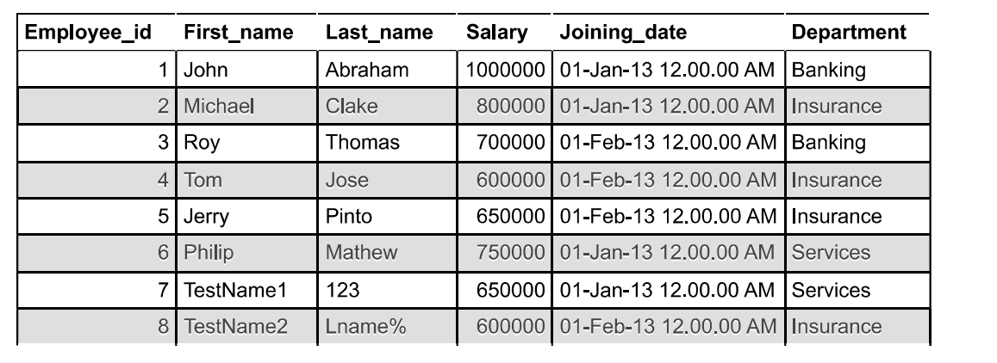

Incentive

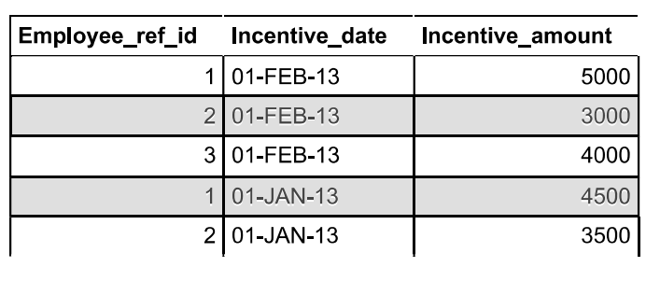

a)Get First_Name from employee table using Tom name “Employee Name”.

ans:SELECT `First_name` FROM `employee` WHERE First_name = 'tom'

b)Get FIRST_NAME, Joining Date, and Salary from employee table.

ans:SELECT First_name,Joining_date,Salary FROM `employee`

c) Get all employee details from the employee table order by First_Name

Ascending and Salary descending?

ans:SELECT * FROM `employee` ORDER BY `First_name` ASC

SELECT * FROM `employee` ORDER BY `Salary` DESC

d) Get employee details from employee table whose first name contains ‘J’

ans:

ELECT *

FROM Employee

WHERE First_name LIKE '%J%'

e) Get department wise maximum salary from employee table order by salary

ascending?

ans:

SELECT Department,Salary FROM employee GROUP BY Department HAVING MAX(Salary) ORDER BY Salary ASC

f) Select first_name, incentive amount from employee and incentives table for

those employees who have incentives and incentive amount greater than 3000

ans:

SELECT`employee`.`First_name`,`incentive`.`Incentive_amount` FROM `employee`,`incentive`GROUP BY `First_name`HAVING (`Incentive_amount`) >3000

g) Create After Insert trigger on Employee table which insert records in view

table

ans:

DELIMITER $$

CREATE TRIGGER `n` AFTER INSERT ON `employee` FOR EACH ROW

BEGIN

INSERT INTO`employee` SET `employee` = `employee`;

end$$